|  |  |  |  |  |  |  |  |  |  |  |  |
| --- | --- | --- | --- | --- | --- | --- | --- | --- | --- | --- | --- |
| **Table 1.** Patient Demographics for Sinonasal Cancer Surgery | | | | | | | | | | | |
|  |  | | **High Volume Centers  (>5 Cases/Year)** | | | | **Low Volume Centers (>5 Cases/Year)** | | | |  |
| Age, mean (SD) | | | 59.8 ± 14.3 | | | | 62.0 ± 17.2 | | | |  |
|  |  | |  | |  | | | |  | | |
| Sex, n (%) | Female | | 424 (40.0) | | | | | 1214 (43.5) | | |  |
|  | Male | | 633 (60.0) | | | | | 1568 (56.2) | | |  |
|  |  |  | |  | | | |  | |  | |
| Race, n (%) | White | | 632 (59.6) | | | | | 1424 (51.1) | | |  |
|  | Black | | 53 (5.0) | | | | | 214 (7.7) | | |  |
|  | Hispanic | | 54 (5.1) | | | | | 163 (5.8) | | |  |
|  | Asian/Pacific Islander | | 30 (2.8) | | | | | 65 (2.3) | | |  |
|  | Native American | | 1 (0.1) | | | | | 9 (0.0) | | |  |
|  | Other or unknown | | 271 (26.0) | | | | | 879 (31.5) | | |  |
|  |  | |  | |  | | | |  | | |  |
| Primary payer, n (%) | Private | | 440 (41.5) | | | | | 1288 (46.2) | | |  |
| Medicaid | | 69 (6.5) | | | | | 214 (7.7) | | |  |
|  | Medicare | | 480 (45.2) | | | | | 1066 (38.2) | | |  |
|  | Self-pay | | 40 (3.8) | | | | | 75 (2.7) | | |  |
|  | Other or unknown | | 27 (2.5) | | | | | 110 (3.9) | | |  |
|  |  | |  | |  | | | |  | | |  |
| **Total, n (%)** |  | | **1061(28.5)** | | | **2789 (71.5)** | | | | |  |

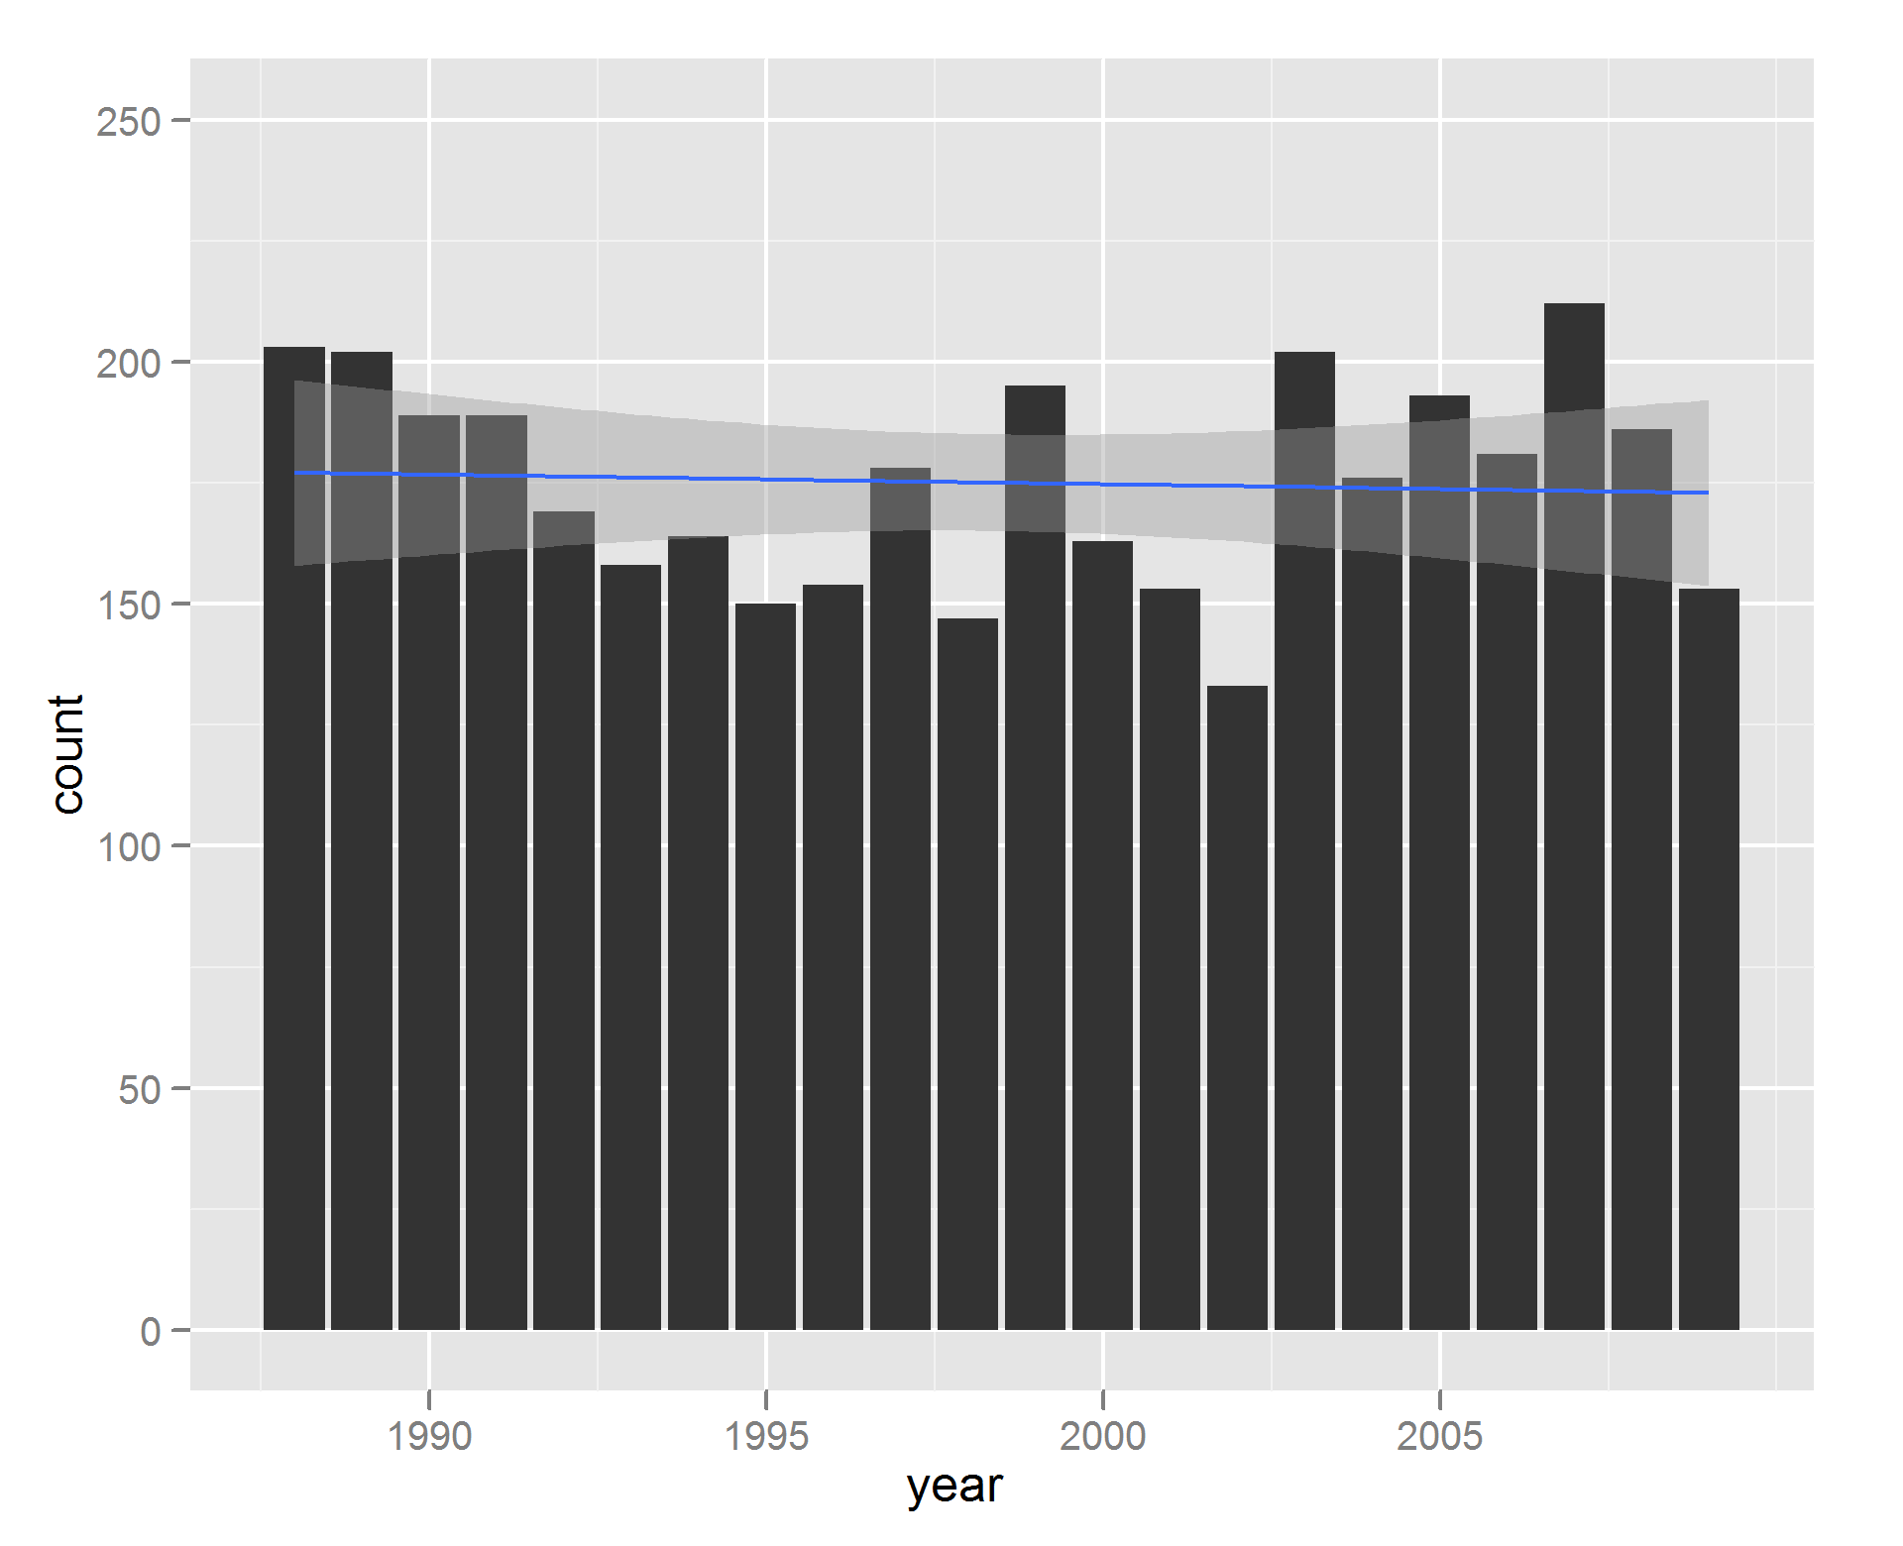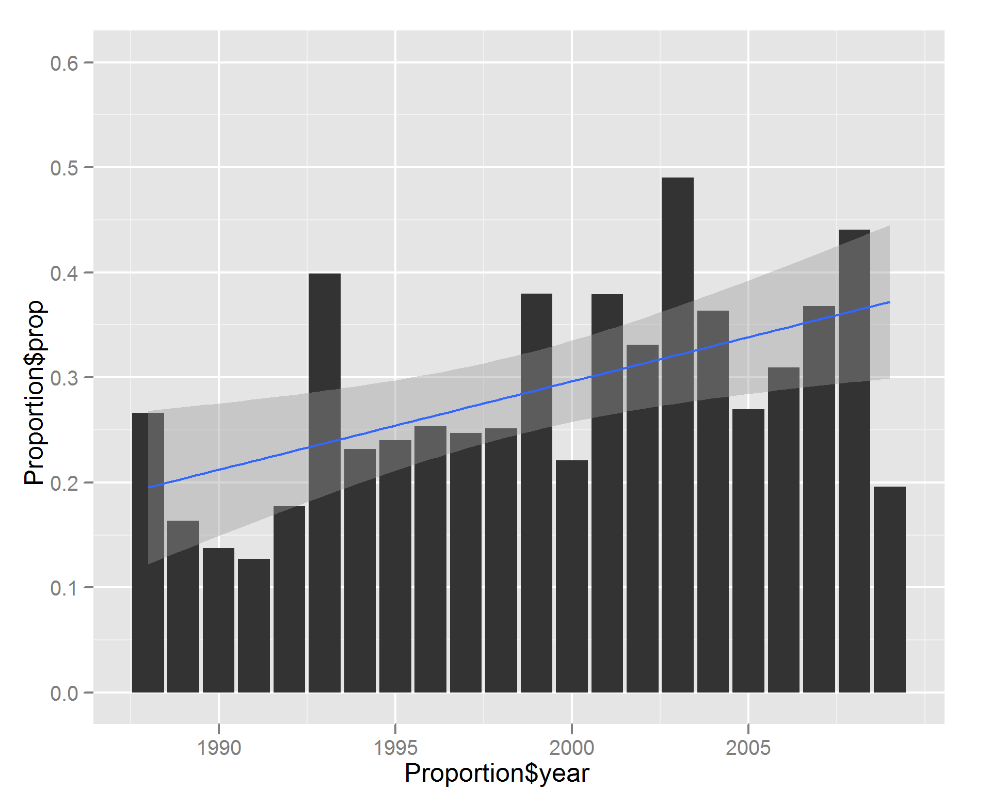

**Figure 1: The number of sinonasal cancer surgeries has not changed significantly over the last twenty years, however an increasing proportion of these surgeries are performed at high volume centers. A: Total number of sinonasal cancer surgeries per year. B: Proportion of sinonasal cancer surgeries performed at high volume centers per year.**

|  |  |  |  |  |  |  |
| --- | --- | --- | --- | --- | --- | --- |
| **Table 2.** Number of Hospitals, Sinonasal Cancer Surgeries Stratified by Hospital Caseload | | | | | |  |
|  | **1988 to 2009** | | | | |  |
|  | **Hospitals, n (%)** | **Cases (%)** | **Cases with Neck Dissection (%)** | **Cases with Orbital Involvement (%)** | **Cases with  Skull Base Involvement (%)** | **Complicated Cases,  Total (%)** |
| High Volume Hospitals (>5 Cases/Year) | 32 (3.6) | 1061 (28.5) | 79 (32.4) | 106 (44.6) | 128 (43.1) | 277 (38.7) |
| Low Volume Hospitals (<5 Cases/Year) | 847 (96.4) | 2789 (71.5) | 165 (67.6) | 130 (53.4) | 169 (56.9) | 418 (61.3) |
| **Total** | **879 (100)** | **3,850 (100)** | **244 (100)** | **236 (100)** | **297 (100)** | **715 (100)** |
|  |  |  |  |  |  |  |

|  |  |  |  |  |  |  |  |  |
| --- | --- | --- | --- | --- | --- | --- | --- | --- |
| **Table 3.** Hospital Characteristics of Admissions for Sinonasal Cancer Surgery | | | | | | | | |
|  | |  | **High Volume Centers  (>5 Cases/Year)**a | | | **Low Volume Centers (>5 Cases/Year)**a | |  |
| Hospital size, n (%)b | Small | | 3 (10.0) | | | 113 (13.6) | | |
| Medium | | 5 (16.7) | | | 254 (30.7) | | |
|  | Large | | 22 (73.3) | | | 461 (55.7) | | |
|  |  | |  |  | | |  | |  |
| Hospital type, n (%) | Teaching | | 27 (90.0) | | | 346 (41.8) | | |
| Non-teaching | | 3 (10.0) | | | 482 (58.2) | | |
|  |  | |  |  | | |  | |  |
| Hospital location, n (%) | Urban | | 29 (96.7) | | | 707 (85.4) | | |
| Non-urban | | 1 (3.3) | | | 121 (14.6) | | |
|  |  | |  |  | |  | | |  |
| Complex Cases,  n (%)c | Neck Dissection | | 79 (7.4) | | | 165 (5.9) | | |  |
| Orbital Involvement | | 106 (10.0) | | | 130 (4.7) | | |  |
| Skull Base Involvement | | 128 (12.0) | | | 169 (6.1) | | |  |
|  | |  |  |  | |  | | |  |
| **Total, n (%)** | |  | **32 (100.0)** | | **847 (100.0)** | | |  |
| Data are cumulative, 1988-2009. aHospital characteristics were not found for 2 high volume hospitals and 19 low volume hospitals.  bHospital size classification is dependent on number of beds and hospital type. For example, for urban, teaching hospitals, “small” signifies < 300 beds and “large” signifies > 500 beds. cPercentage obtained from total number of cases by each subset | | | | | | | | |

|  |  |  |  |  |  |  |  |
| --- | --- | --- | --- | --- | --- | --- | --- |
| **Table 4.** Complications of Sinonasal Cancer Surgery | | | | | | | |
|  | **Total** | **High-Volume Centers** | | **Low-Volume Centers** | | | **Pa** |
| Deaths, n (%) | 30 (0.8) | 4 (0.4) | | 26 (0.9) | | 0.122 | |
|  |  |  | |  |  | | |
| Infectious, n (%) |  |  | |  | | 0.119 | |
| Surgical Site Infection | 70 (1.8) | 14 (1.3) | | 56 (2.0) | |  | |
| Urinary Tract Infections (UTIs) | 71 (1.8) | 16 (1.5) | | 55 (2.0) | |  | |
| Pneumonia | 30 (0.8) | 9 (0.8) | | 21 (0.8) | |  | |
| Unspecified Postop Infection | 17 (0.4) | 3 (0.2) | | 14 (0.5) | |  | |
|  |  |  | |  | |  | |
| Cardiopulmonary, n (%) |  |  | |  | | 0.024b | |
| Stroke | 16 ((0.4) | 8 (0.8) | | 8 (0.3) | |
| Cardiac Arrest | 8 (0.2) | 1 (0.1) | | 7 (0.3) | |  | |
| Other Cardiac Complications | 456 (11.8) | 127 (12.0) | | 329 (11.8) | |  | |
| Pulmonary Complications | 239 (6.2) | 87 (8.2) | | 152 (5.4) | |  | |
|  |  |  | |  | |  | |
| Other, n (%) |  |  | |  | |  | |
| Neuropathies  Visual Impairment | 51 (1.3) | 13 (1.2) | | 38 (1.4) | | 0.861 | |
| 76 (2.0) | 20 (1.9) | | 56 (2.0) | | 0.908 | |
| Hemorrhage | 46 (1.2) | 12 (1.1) | | 34 (1.2) | | 0.953 | |
| Electrolyte Abnormalities | 312 (8.1) | 110 (10.4) | | 202 (7.2) | | 0.002b | |
|  |  |  |  | | |  | |
| **Total Complications** | **1392 (36.9)** | 424 (40.0) | | 998 (35.8) | | 0.018b | |
| aChi Square Test Comparing High-Volume and Low-Volume Centers. b P < 0.05 | | | | | | | |

Supplemental Figures

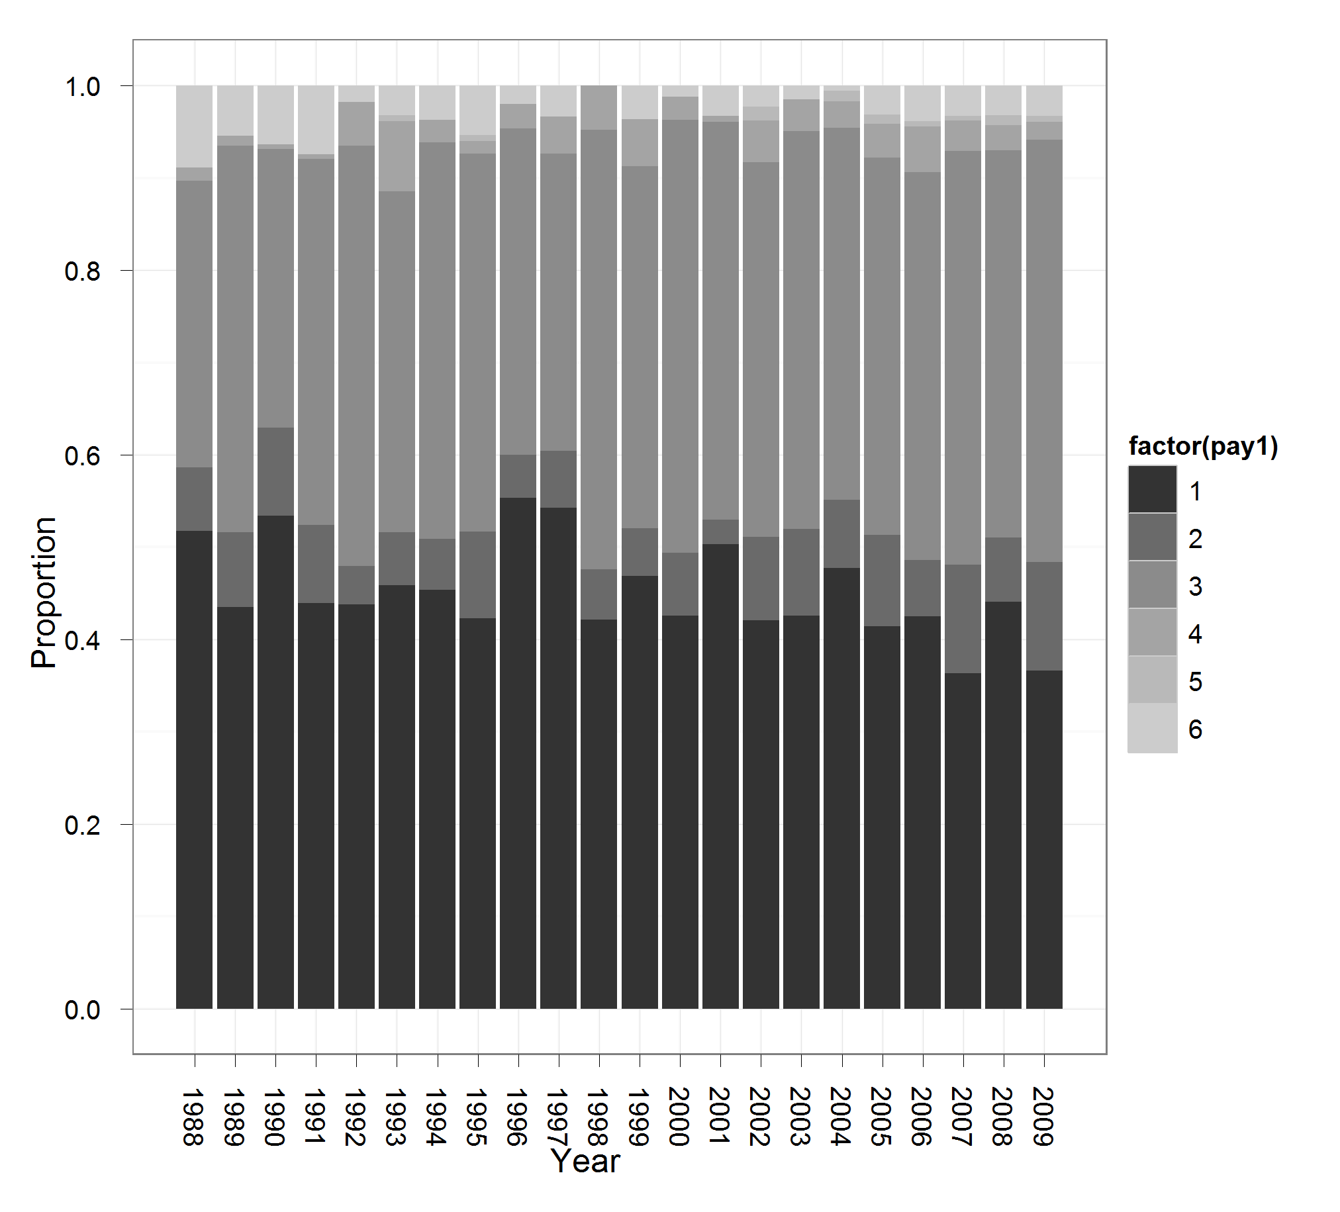

Figure A: Patient Insurance Status Over Time

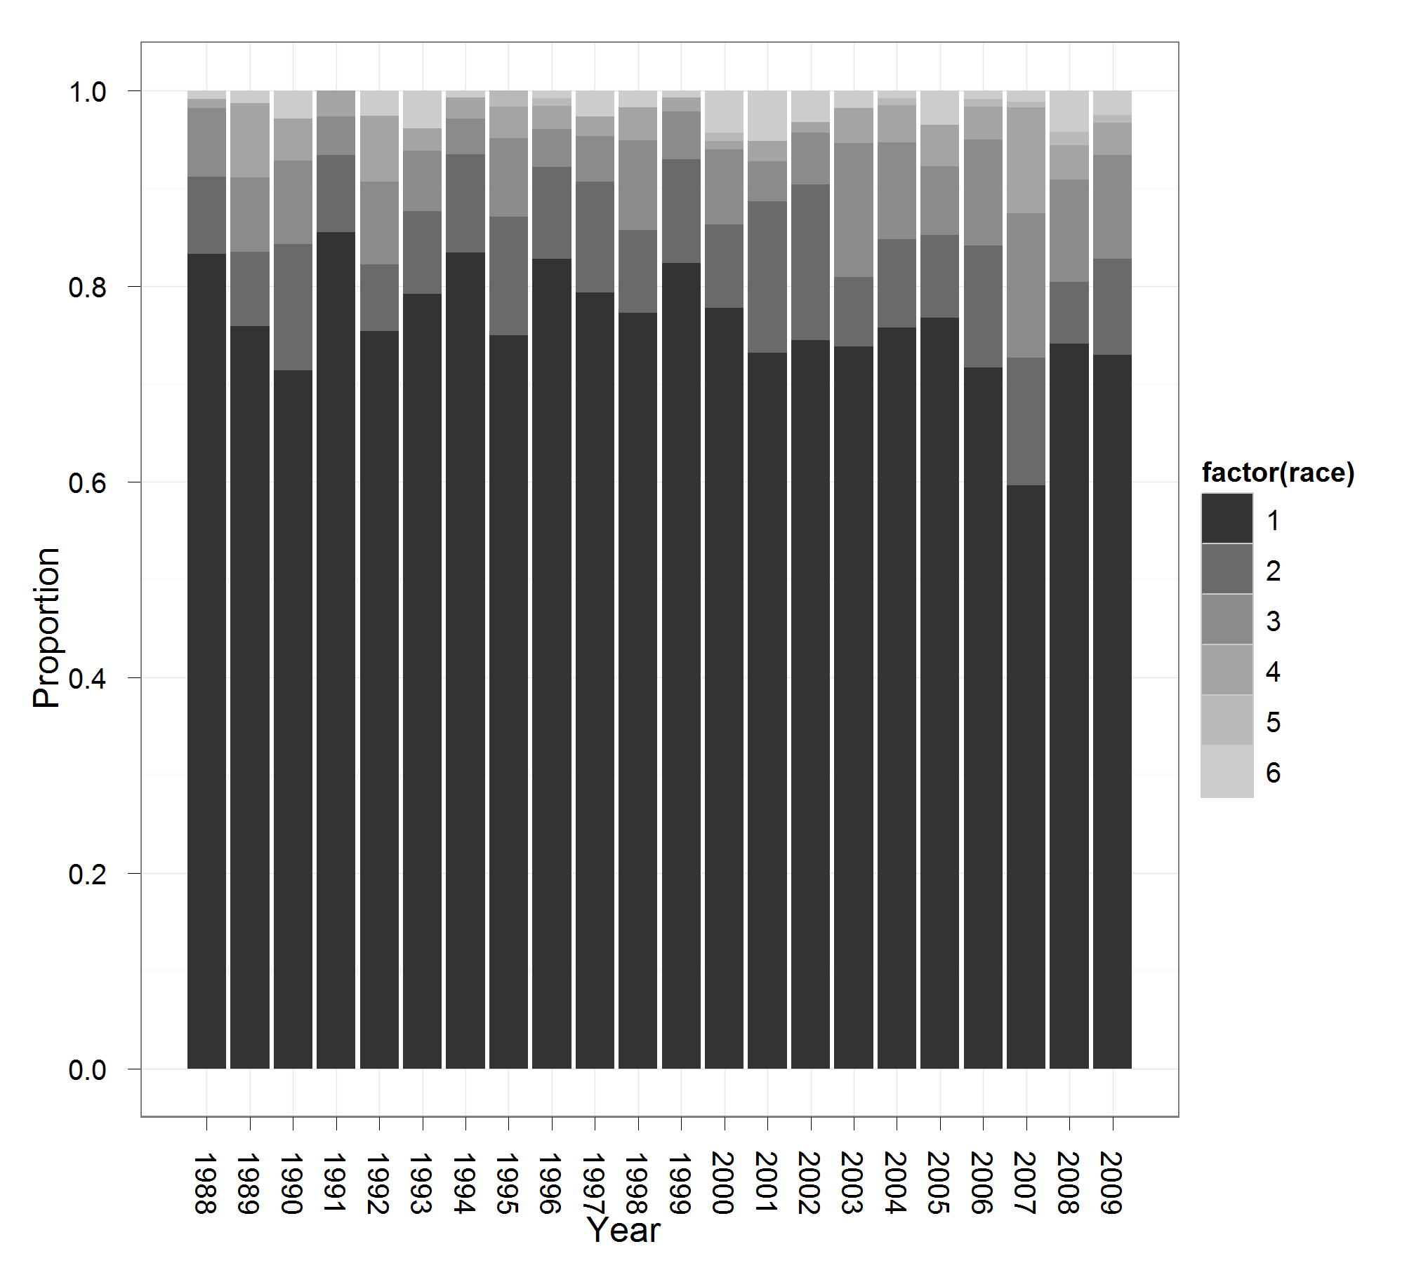

Figure B: Race Over Time

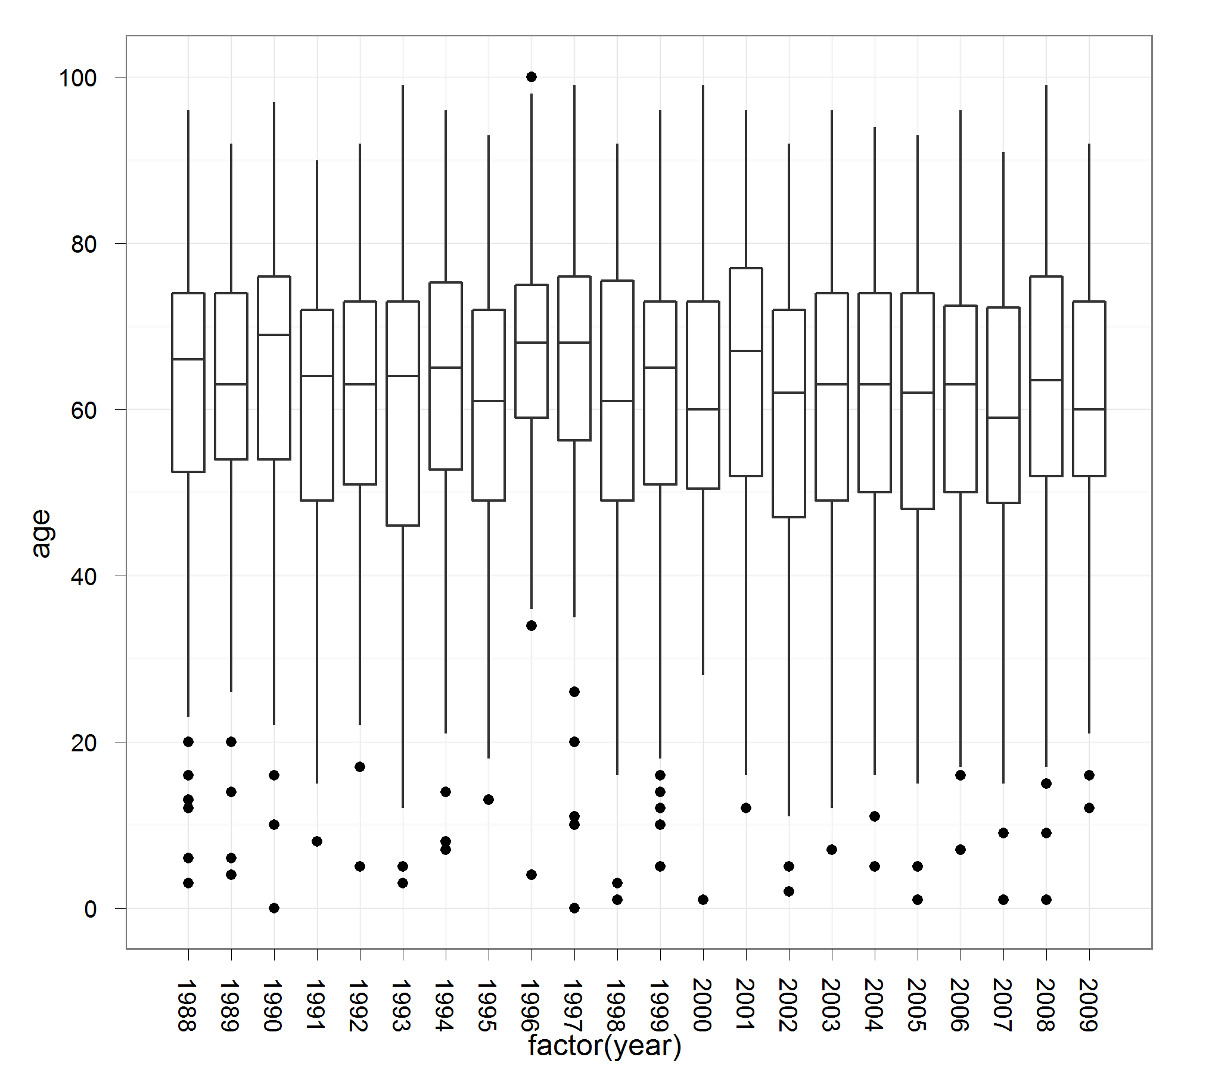

Figure C: Age Over Time

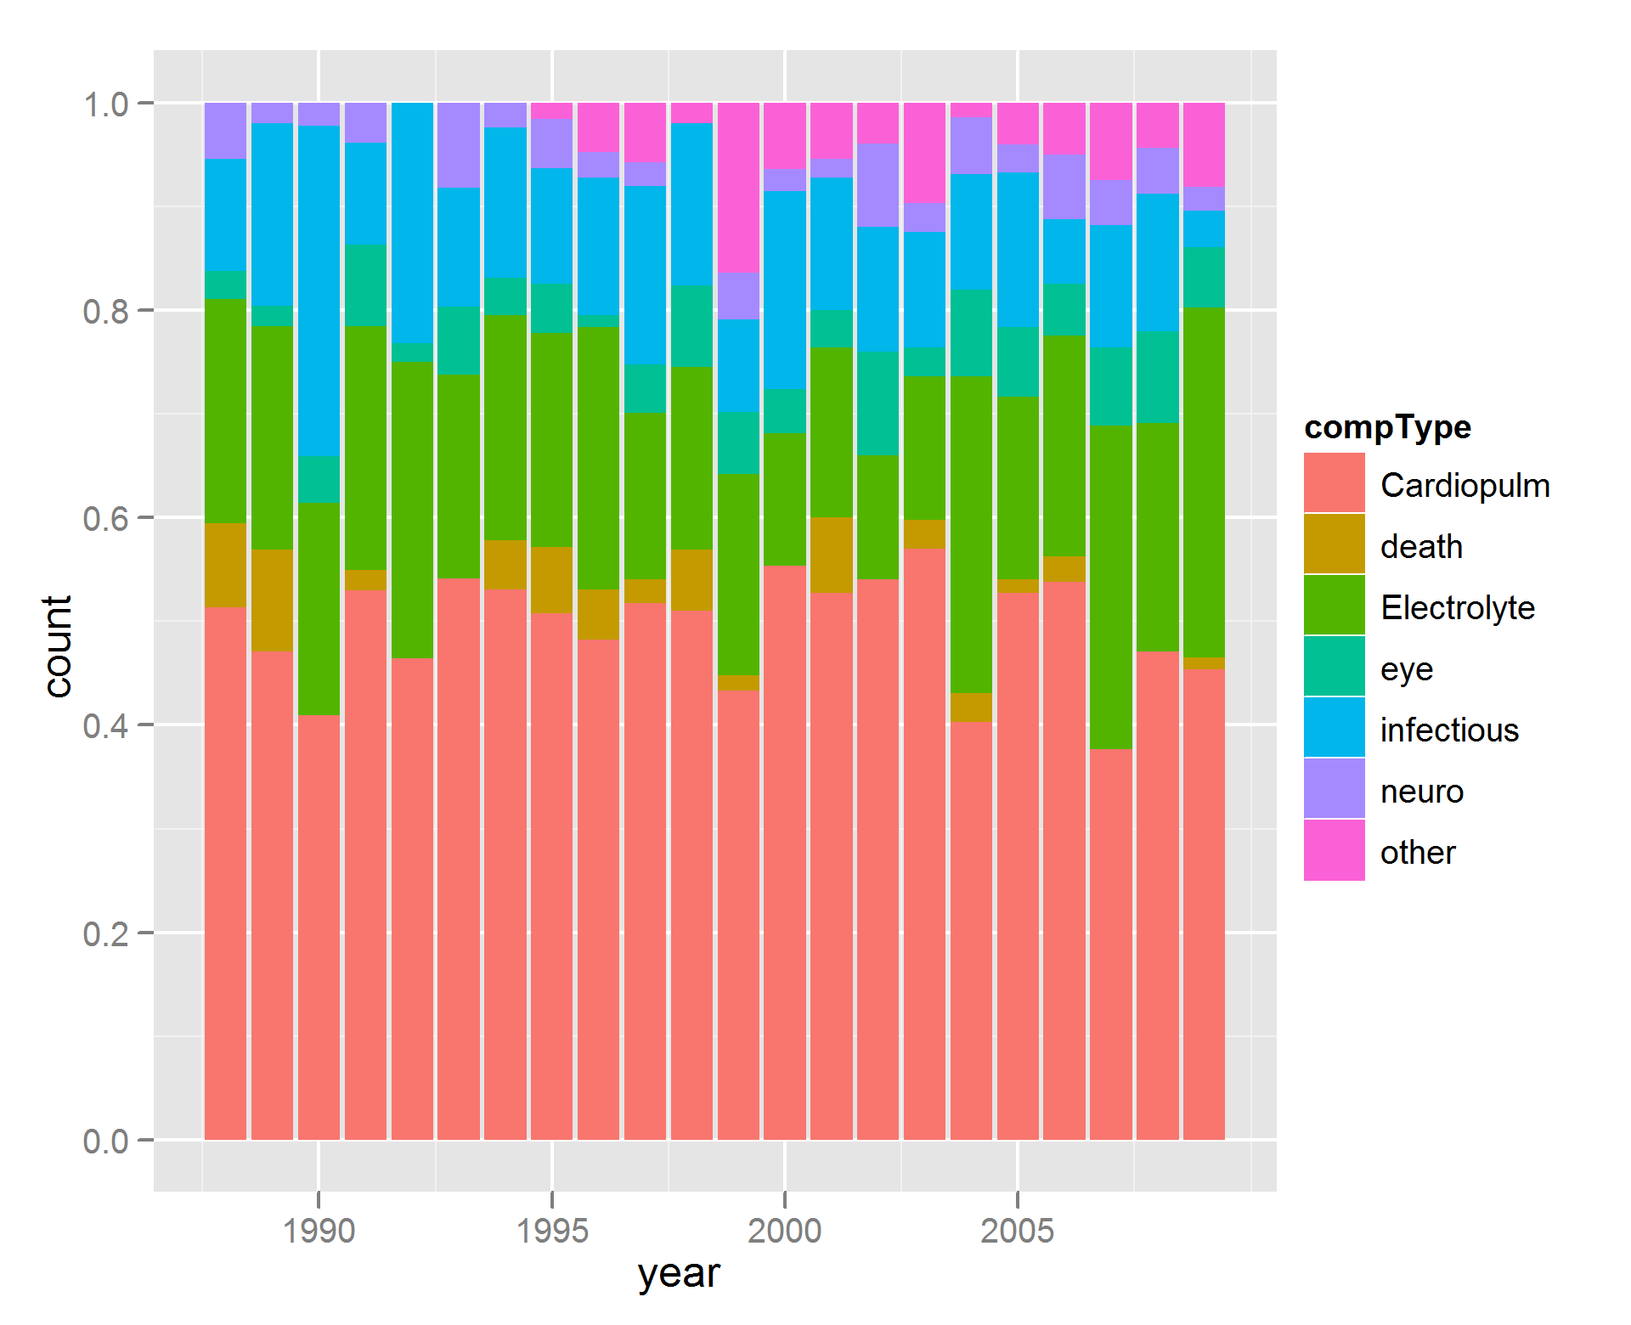

**Supplemental Figure D: Rate and Make-up of Complications over Time (by Year)**